0 Update and Upgrade Woo Choice Plugin
Woo Choice Plugin Update and Upgrade Instruction

1 Upload Or Upgrade Extension files using respective FTP

1.1 “master_QCed_bhavesh_1” branch should be uploaded

1.2 New upload ke update karta hoy tyare .git folders upload nahi karvana

1.3 .gitignore file pan upload nahikarvani

1.4 React related koi pan folder hoy asset ke assets to e upload nathi karvanu

2. Follow the Git Submodule document
2.1 This extension has the below submodule dependency
- sp_ssm_themes
- “master_QCed_bhavesh_1” branch should be uploaded

3. In the Admin panel, Go to Plugins

3.1 Find the uploaded or upgraded plugin by its name from the plugins list and ensure it is activated if it is newly uploaded or upgraded.

3.2 Click on the Admin Panel of the Book An appointment
3.2.1 In General Tab
Select Slick Template in “Select Template”
Page Template” and save it
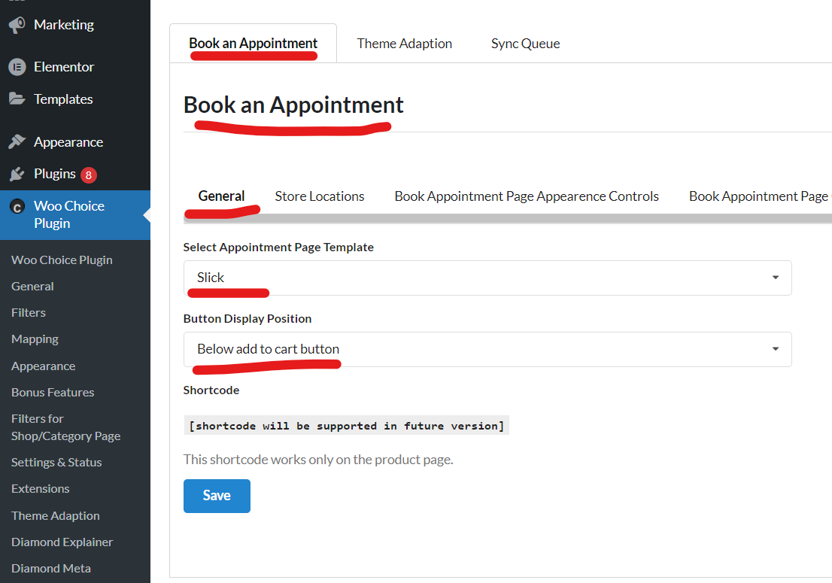

3.2.2 In-Store Locations Tab
Add below locations as added in the comment section
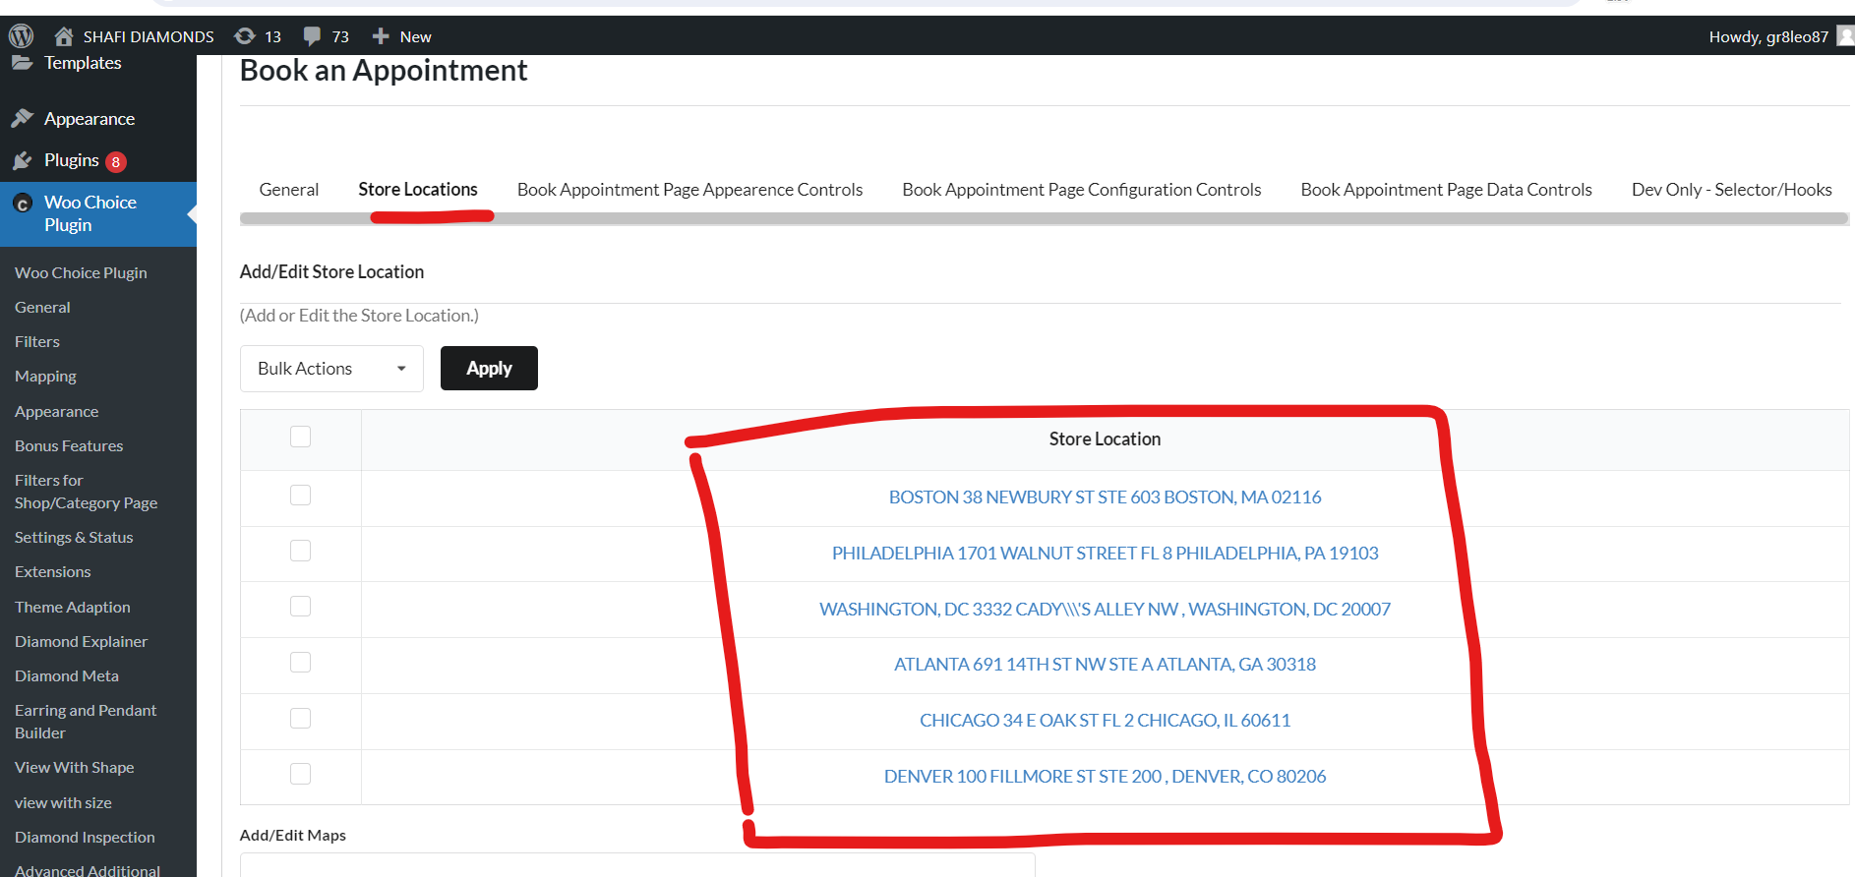

Note: Test properly for activated and setup plugin on the preview page of a ring or any other builder page respectively

For Conversion Optimisation

For better conversion do not select the root ring build(pair builder) categories. For ex. Rings, earrings, pendants, and so on in the for categories field on the admin panel book appointment do not show up on the preview page.

